Experiment-12

**Name :-** Aryan Langhanoja

**Enrollment No :-** 92200133030

**Aim:** Hands-on experimentation of I2C Programming with ATMEGA32 in C .

**Objectives:** After successfully completion of this experiment students will be able to,

* Use C language for ATMega32 microcontroller programming on AVRStudio.
* Experiment with I2C programming with ATMega32 on ATMega32 AVR Development Board.

# Equipment required:

* Windows7 or later based host computer
* ATMega32 Development board
* USBasp Programmer
* Jumper Wires
* Peripherals

# Software required:

* AVR Studio7 installation setup
* USBasp driver installation setup

# Theory:

# I2C in AVR ATmega16/ATmega32

I2C (Inter-Integrated Circuit) is a serial bus interface connection protocol. It is also called TWI (two-wire interface) since it uses only two wires for communication, that two wires called SDA (serial data) and SCL (serial clock). AVR-based ATmega16/ATmega32 has a TWI module made up of several submodules as shown in the figure.

I2C works in two modes namely,

* Master mode
* Slave mode

Let see registers in the ATmega16/32 I2C module

TWBR: TWI Bit Rate Register

TWI bit rate register used in generating SCL frequency while operating in master mode



TWCR: TWI Control Register

TWI control resistor used to control events of all I2C communication.



Bit 7 – TWINT: TWI interrupt

* This bit gets set whenever TWI completes its current event (like start, stop, transmit, receive, etc).
* While I-bit in SREG and TWIE bit in TWCR is enabled then TWI interrupt vector called whenever TWI interrupt occur.
* TWI interrupt flag must be cleared by software by writing a logical one to it. This bit is not automatically cleared by hardware.

Bit 6 – TWEA: TWI enable acknowledgment bit

* This is TWI acknowledgment enable bit, it is set in receiver mode to generate acknowledgment and cleared in transmit mode.

Bit 5 – TWSTA: TWI START condition bit

* The master device set this bit to generate START condition by monitoring free bus status to take control over the TWI bus.

Bit 4 – TWSTO: TWI STOP condition bit

* The master device set this bit to generate STOP condition to leave control over the TWI bus.

Bit 3 – TWWC: TWI write collision

* This bit gets set when writing to the TWDR register before the current transmission not complete i.e. TWINT is low.

Bit 2 – TWEN: TWI enable bit

* This bit set to enables the TWI interface in the device and takes control over the I/O pins.

Bit 1 - Reserved

Bit 0 – TWIE: TWI interrupt enable

* This bit is used to enable TWI to interrupt routine while the I-bit of SREG is set as long as the TWINT flag is high.

TWSR: TWI Status Register



Bit 7:Bit 3 - TWS7: TWS3: TWI status bits

* TWI status bits shows the status of TWI control and bus

Bit 1:0 - TWPS1:TWPS0: TWI pre-scaler bits

* TWI pre-scaler bits used in bit rate formula to calculate SCL frequency

| TWPS1 | TWPS0 | Exponent | Pre-scaler value |
| --- | --- | --- | --- |
| 0 | 0 | 0 | 1 |
| 0 | 1 | 1 | 4 |
| 1 | 0 | 2 | 16 |
| 1 | 1 | 3 | 64 |

TWDR: TWI Data Register

* TWDR contains data to be transmitted or received.
* It’s not writable while TWI is in process of shifting a byte.
* The data remains stable as long as TWINT is set.



TWAR: TWI Address Register

* TWAR register contains the address of the TWI unit in slave mode.
* It is mostly used in the multi-master system.



Bit 7:1 - TWA6: TWA0: TWI address bits

* TWI address bits contain TWI 7-bit address with which it can called by other masters in slave mode.

Bit 0 – TWGCE: TWI general call enable bit

* TWI general call enable bit when set it enables recognition of general call over the TWI bus

There are four transmission modes in I2C in which the I2C device works.

* When the device is Master it works in MT and MR transmission modes.
* And when the device is Slave it works in ST and SR transmission modes.

| SR No. | Transmission mode | Operation |
| --- | --- | --- |
| 1 | Master Transmitter (MT) | Master device writes data to SDA. |
| 2 | Master Receiver (MR) | Master device read data from SDA. |
| 3 | Slave Transmitter (ST) | Slave device writes data to SDA. |
| 4 | Slave Receiver (SR) | Slave device read data from SDA. |

**I2C Interfacing Diagram:**

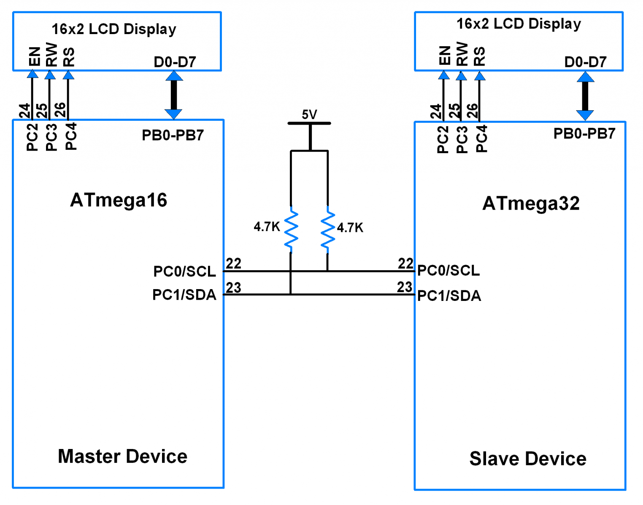

Programming steps for Write operation:

1. Initialize I2C.
2. Generate START condition.
3. Send the Slave device to write address (SLA+W) and check for acknowledgment.
4. Write memory location addresses for memory devices to which we want to write.
5. Write data till the last byte.
6. Generate a STOP condition.

Programming steps for reading operation:

1. Initialize I2C.
2. Generate START condition.
3. Write device Write address (SLA+W) and check for acknowledgment.
4. Write a memory location address for memory devices.
5. Generate REPEATED START condition.
6. Read data and return acknowledgment.
7. Return Not acknowledgment for the last byte.
8. Generate a STOP condition.

ATmega32 I2C Master Program:

#define F_CPU 8000000UL /* Define CPU clock Frequency 8MHz */

#include <avr/io.h> /* Include AVR std. library file */

#include <util/delay.h> /* Include Delay header file */

#include <string.h> /* Include string header file */

#include "I2C_Master_H_file.h" /* Include I2C header file */

#include "LCD_16x2_H_file.h" /* Include LCD header file */

#define EEPROM_Write_Addess 0xA0

#define EEPROM_Read_Addess 0xA1

int main(void)

{

char array[10] = "test"; /* Declare array to be print */

LCD_Init(); /* Initialize LCD */

I2C_Init(); /* Initialize I2C */

I2C_Start(EEPROM_Write_Addess);/* Start I2C with device write address */

I2C_Write(0x00); /* Write start memory address for data write */

for (int i = 0; i<strlen(array); i++)/* Write array data */

{

I2C_Write(array[i]);

}

I2C_Stop(); /* Stop I2C */

_delay_ms(10);

I2C_Start(EEPROM_Write_Addess);/* Start I2C with device write address */

I2C_Write(0x00); /* Write start memory address */

I2C_Repeated_Start(EEPROM_Read_Addess);/* Repeat start I2C SLA+R */

for (int i = 0; i<strlen(array); i++)/* Read data with acknowledgment */

{

LCD_Char(I2C_Read_Ack());

}

I2C_Read_Nack(); /* Read flush data with nack */

I2C_Stop(); /* Stop I2C */

return 0;

}

# ATMEGA32 Slave Program:

#define F_CPU 8000000UL /* Define CPU clock Frequency 8MHz */

#include <avr/io.h> /* Include AVR std. library file */

#include <util/delay.h> /* Include inbuilt defined Delay header file */

#include <stdio.h> /* Include standard I/O header file */

#include <string.h> /* Include string header file */

#include "LCD_16x2_H_file.h" /* Include LCD header file */

#include "I2C_Slave_H_File.h" /* Include I2C slave header file */

#define Slave_Address 0x20

int main(void)

{

char buffer[10];

int8_t count = 0;

LCD_Init();

I2C_Slave_Init(Slave_Address);

LCD_String_xy(1, 0, "Slave Device");

while (1)

{

switch(I2C_Slave_Listen()) /* Check for SLA+W or SLA+R */

{

case 0:

{

LCD_String_xy(2, 0, "Receiving : ");

do

{

sprintf(buffer, "%d ", count);

LCD_String_xy(2, 13, buffer);

count = I2C_Slave_Receive(); /* Receive data byte*/

} while (count != -1); /* Receive until STOP/REPEATED START */

count = 0;

break;

}

case 1:

{

int8_t Ack_status;

LCD_String_xy(2, 0, "Sending : ");

do

{

Ack_status = I2C_Slave_Transmit(count);/* Send data byte */

sprintf(buffer, "%d ",count);

LCD_String_xy(2, 13, buffer);

count++;

} while (Ack_status == 0); /* Send until Ack is receive */

break;

}

default:

break;

}

}

# }

# Circuits :

# 